**Lab 5A – Raster Data Processing with GDAL**

This lab is designed to help you master raster data processing with GDAL modules and Python. A Landsat TM image (landsat_tm.img) is provided and your goal is to a) subset (or clip) the image to the spatial extent of the provided shapefile (clip.shp); b) create a new image of NDVI for the subset; and c) create a new binary image from the NDVI image so that all the pixels with a NDVI value greater than 0 have a value of 1 and all the other pixels have a value of 0.

**Note**: Please use -999 to represent NoData.

# landsat_tm.img overlaid with the clip.shp

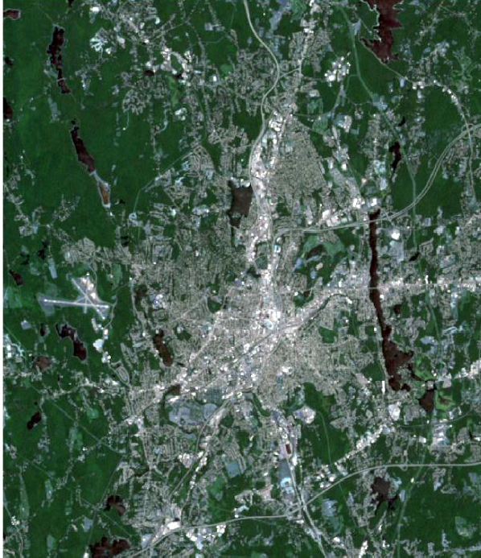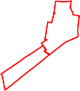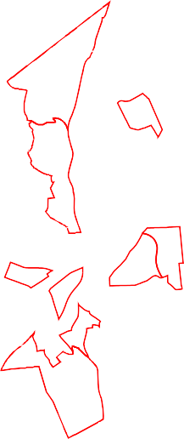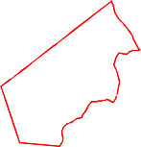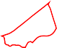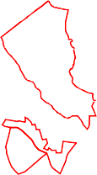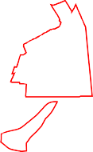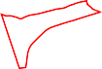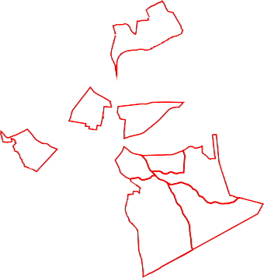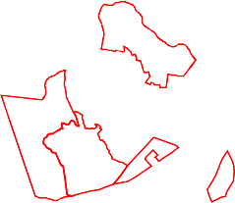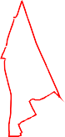

**subset.img ndvi.img binary.img**

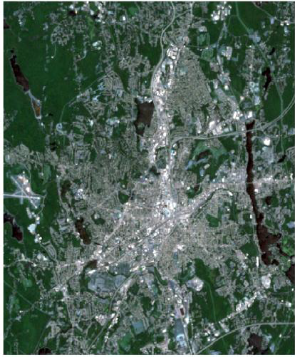 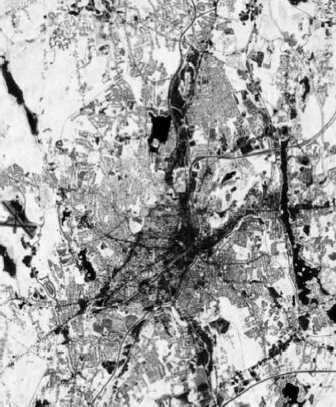 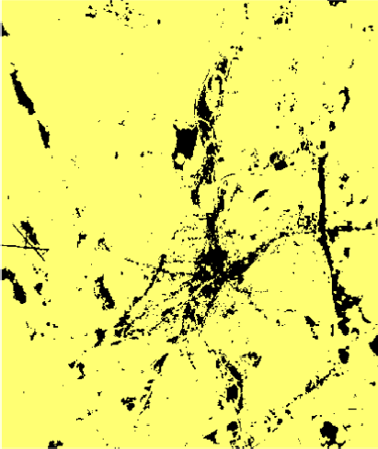

**Deliverable:** a working Python script with detailed comments; a pdf with all the three images generated.

**Note**: your colors may look different because you may use a different symbology.